ANR Scoring & Visualisation software –maps

# Overview

Maps are essential in the ANR Scoring & Visualization software (no parcours without map). The user must understand the basics and pre-requisites for the map import into the ANR software.

Different maps use different coordinate reference systems. There are tens or even hundreds of different coordinate reference systems, many of them country- or region-specific.

The detailed maps that are required in ANR are most likely not in the correct format for the ANR scoring software. ANR needs maps based on the WGS84 coordinate reference system (technically: **EPSG: 4326**).

So the first issue is: **how to get a good map for the competition area in the correct coordinate reference system?**

# Options

There are basically three ways how to tackle the map challenge:

* Option 1- let a 3rd party do the re-projection of your map
* Option 2- use digital map material and do the re-projection yourself
* Option 3- use your own scanned map material and do the re-projection yourself

## Buy a map conversion from a third party

You should be able to from a third party that provides mapping/ map re-projection services. One example for such a 3rd party provider is [www.merkartor.de](http://www.merkartor.de)

You must be able to tell the vendor what you need: you need your original map to be re-projected into the WGS 84 coordinate reference system (technically: **EPSG: 4326**)

You will send your original map either digitally or as a paper map to the provider (maybe the provider will propose himself a suitable map).

What you will get back is a picture file (map in WGS84 coordinate system) and a related so-called world-file (basically a text file with extension *.pgw, *.tfw, *.jgw, *.wld or similar).  
The world-file contains the required information.

You then import these two files into the ANR software (Maps-Import from Worldfile)

## Use suitable digital maps and do the re-projection yourself

An open-source software called QGIS can be used for map re-projection. The video uses as an example Norwegian digital maps

Video: <https://www.youtube.com/watch?v=997MSiTg1Ww>

* Assumes that maps are available in digital format and geo-referenced.
* Shows how to re-project from a (country/region specific) coordinate reference system to WGS 84 Coordinate Reference System
* Shows how to import into the Air Navigation Race (ANR) Scoring & Visualization application

## Scan and import your own maps

Assumes that you do not have digital maps, but you can scan your own (paper) maps. Again, the open-source software called QGIS is used for geo-referencing and map re-projection.

Video: <https://www.youtube.com/watch?v=VDiG4fO4D1c>

* Shows how to geo-reference your scanned maps
* Shows how to re-project from a (country/region specific) coordinate reference system to WGS 84 Coordinate Reference System
* Shows how to import into the Air Navigation Race (ANR) Scoring & Visualization application

The following part of this document focuses on option 3 (the re-projection part described here applies also to option 2)

# Scanning maps

Make sure that the scan quality is sufficient. Check the scan settings: often the standard settings are 200 or 300 DPI. Try using 400…600 DPI. At the same time make sure to limit the picture size. If the scan is too big you will not be able to edit it (and also the import into the ANR software may fail/cause problems).

# What to do – basic steps

When using scanned maps with the ANR Scoring & Visualization software, the following steps are required:

* geo-referencing the scanned map
* re-project the geo-referenced map (from the original map projection to WGS84 projection)
* clipping (if required)

# Geo-referencing the new map file

Open the QGIS desktop application. Select *Raster-Ceoreferencer-Georeferencer….*

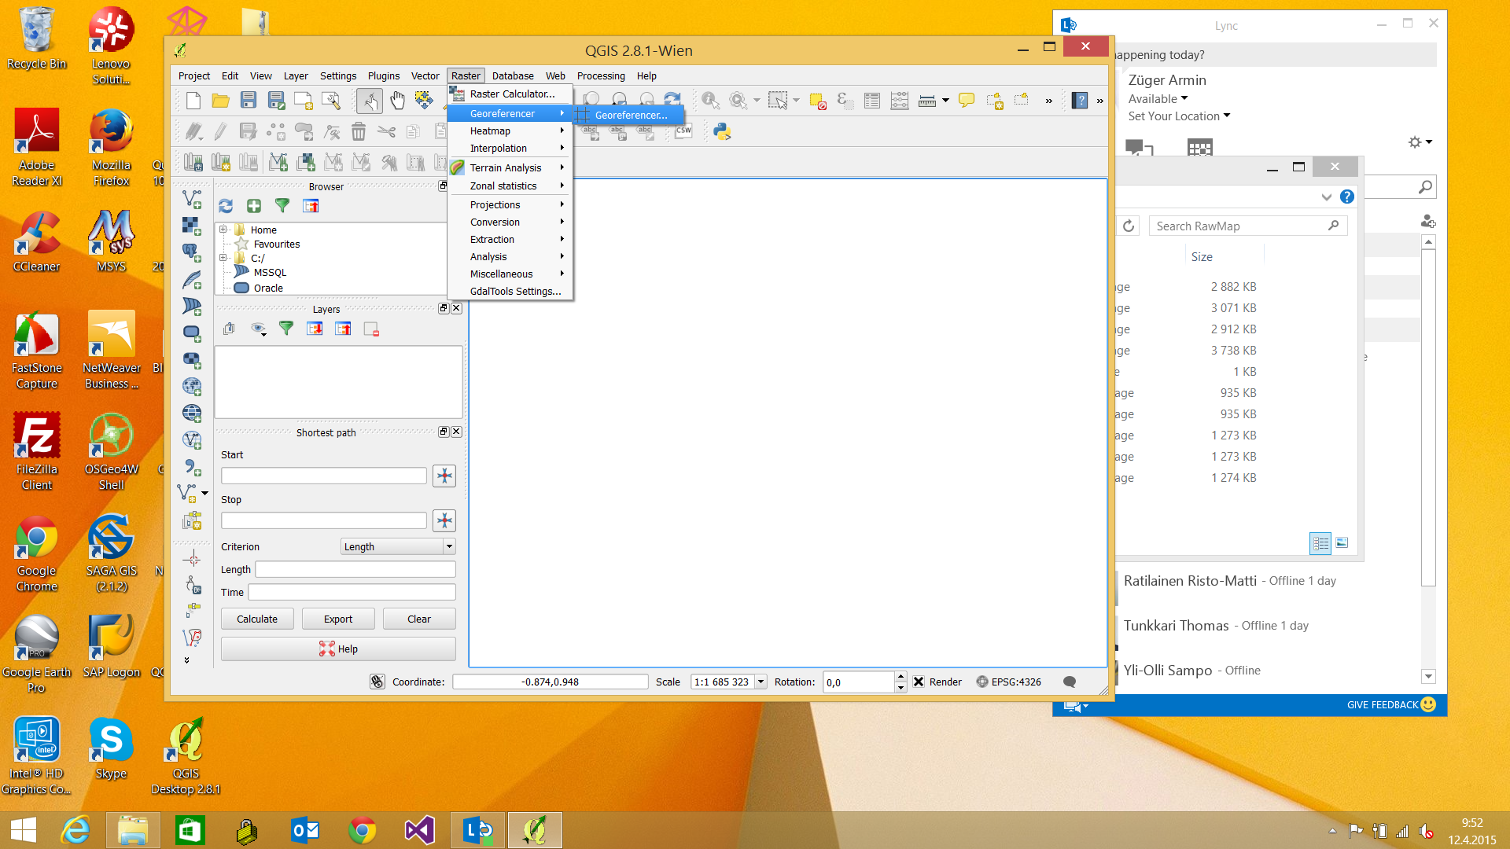

From the new Window, Select *Open Raster* and load the scanned map file. Set the correct Coordinate Reference System (as indicated on the map). The example below uses the Finnish ETRS89, **but (IMPORTANT) you must check which reference system your map uses and set the according reference system in QGIS.**

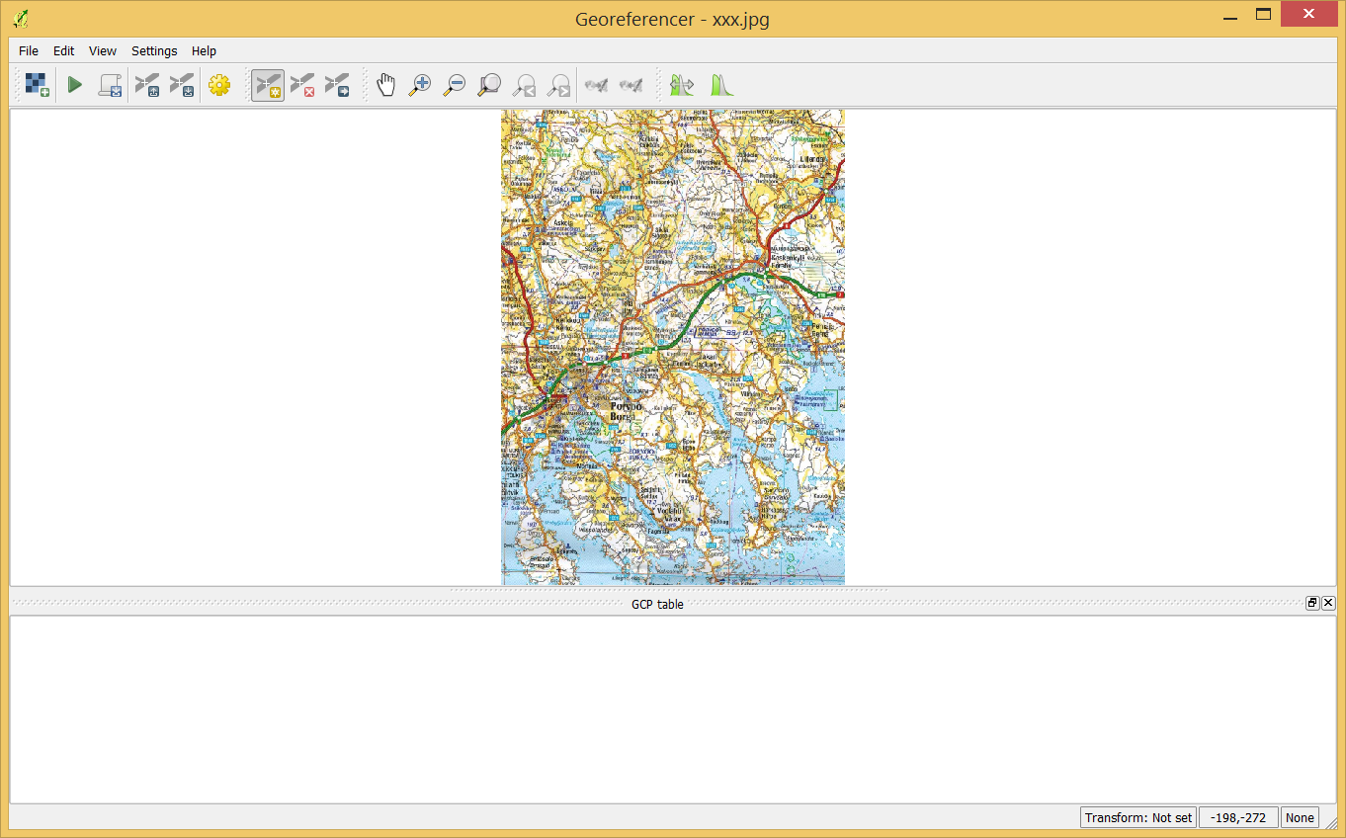 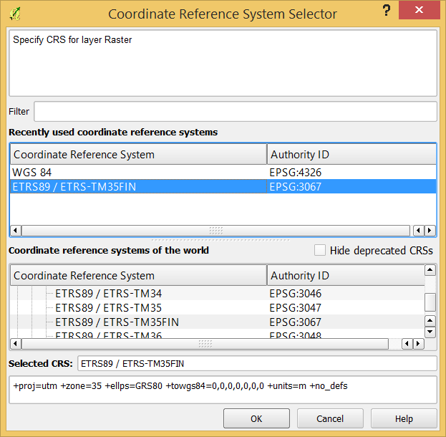

Set reference points (GCP points). The points will be listed beneath the picture. It is recommended to save the points for further use (*Save GCP points as…*)

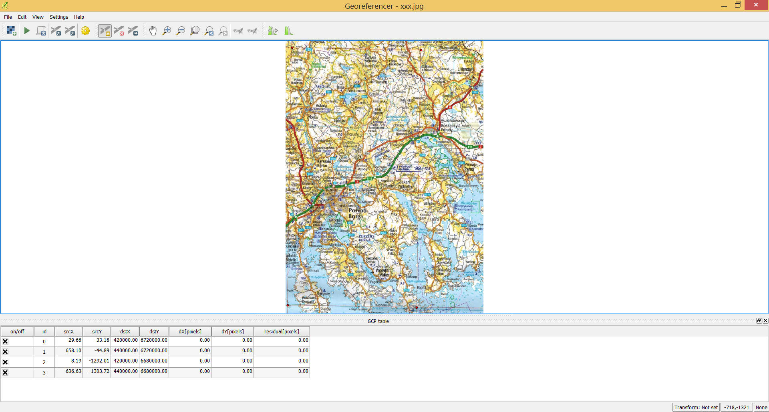

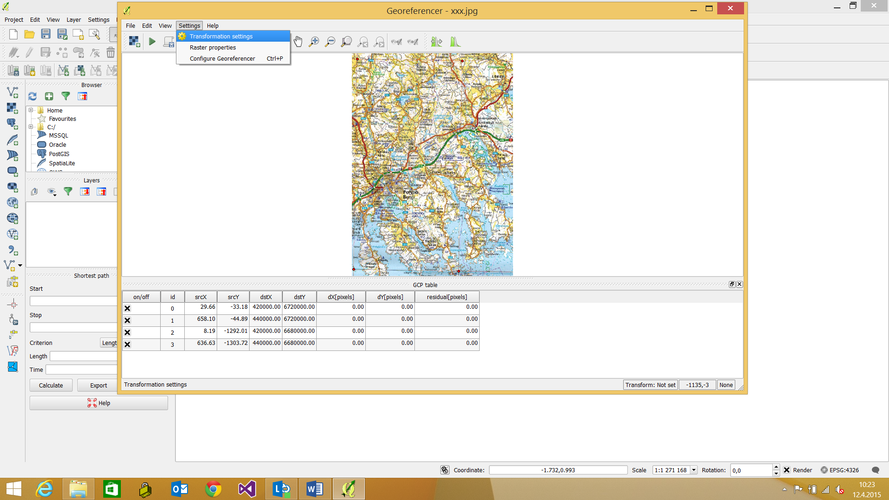 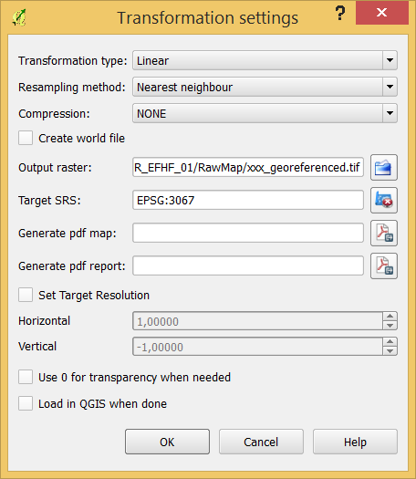

Select *Transformation settings*:

* Name the output raster. In this example the filename is **xxx_georeferenced.tif** (this file will be generated)
* Target SRS: select again the coordinate projection as indicated on the map (often country-specific projections. In your case, this will most likely be something else than EPGS:3067)
* press the green arrow **start georeferencing**
* Check that the output raster file has been created. This file will be used in the next step (Map creation)

NOTE: in case you use free maps in electronic format, then in most cases these maps come with a separate world-file and other metadata information. You can try to load the map file (“Layer”-“Add Layer…”-“Add Raster Layer…”). QGIS often detects the projection already based on these data (you see the selected projection in the right lower corner of the main window).

These free map files might be large, and we need only a small area of it. It this case you can use the **clipping** functionality (described a bit later in this document) to select only the desired part of the map file. You would also in this case append manually the “-co worldfile=yes” to preserve the georeferencing.

# Map projection

On QGIS Desktop, select *Raster-Projections-Warp (Reproject)…*

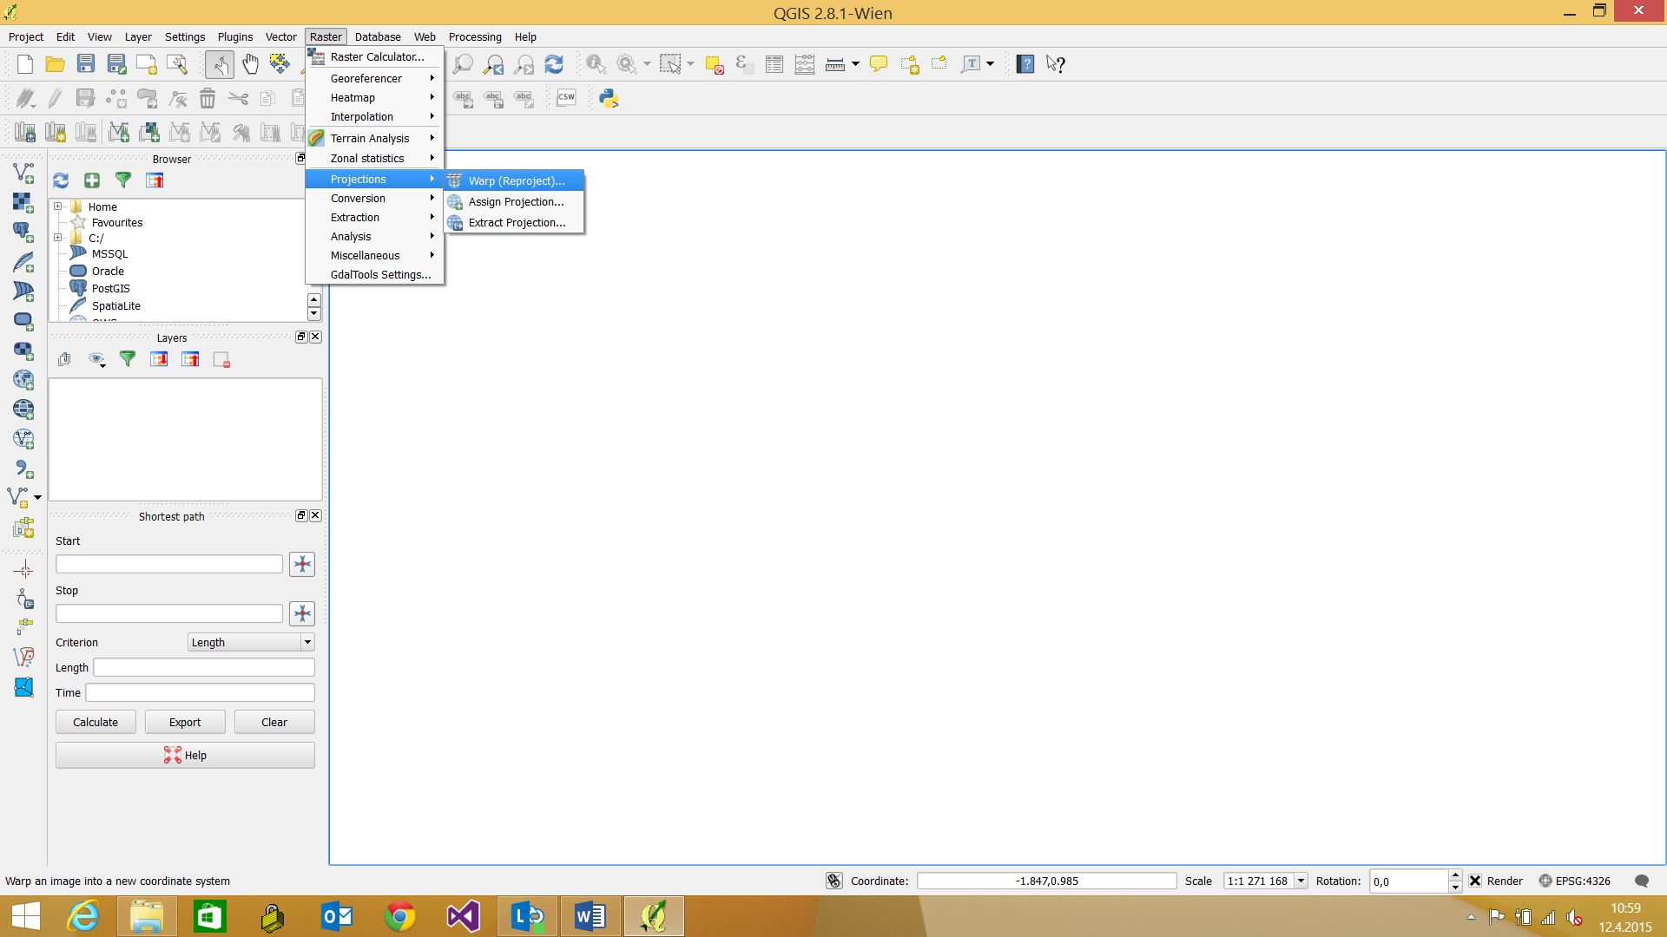

**Input File:** select the georeferenced input file that you have available or scanned yourself from an existing map (in our example, xxx_georeferenced.tiff)

**Output File:** the resultingoutput map file

**Source SRS**: the Coordinate Reference system is the map projection, indicated on the map that you have scanned (as indicated on the map that you scanned)

**Target SRS**: Set the target map projection for the ANR software to **WGS 84**

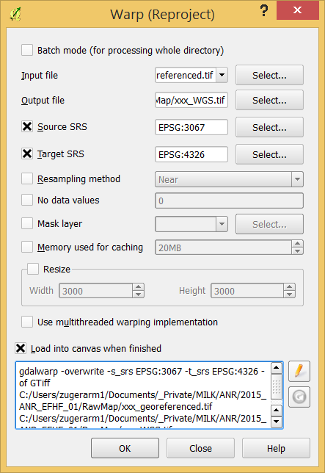 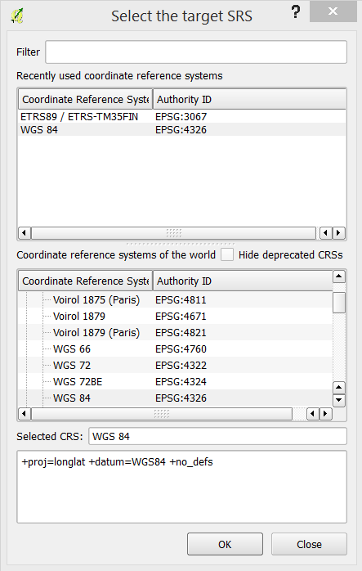

Press the pen icon and add the following thext to the end of the window: **-co worldfile=yes**

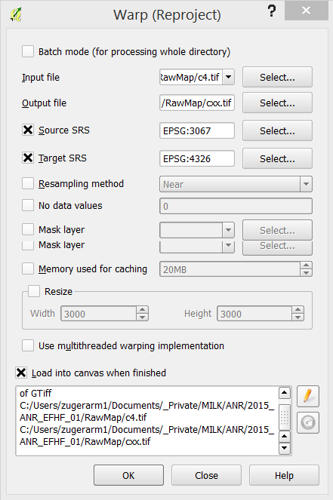

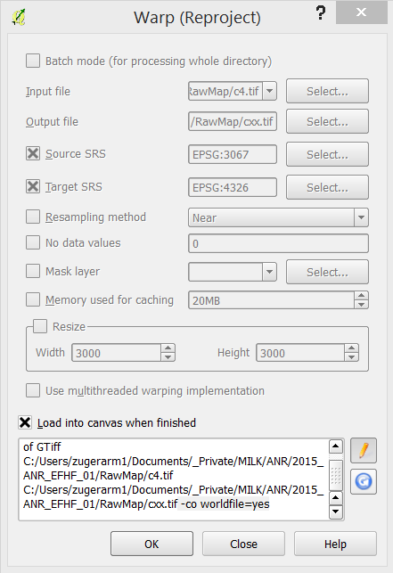

Ignore/close the warnings

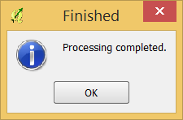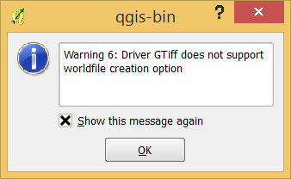

The new projection (WGS84) should now appear in the window:

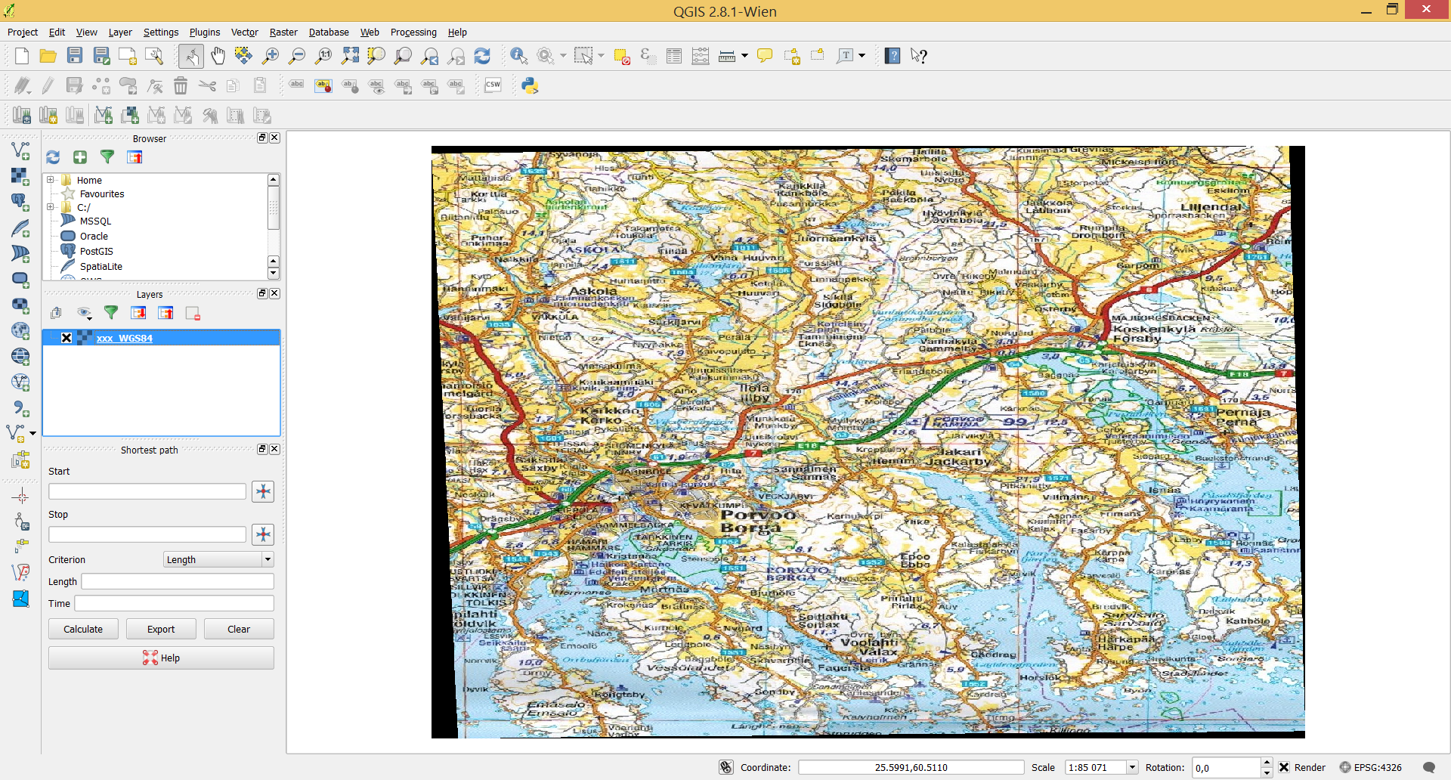

You should find now two new files **xxx_WGS84.TIFF** and **xxx_WGS84.WLD** files in your folders:

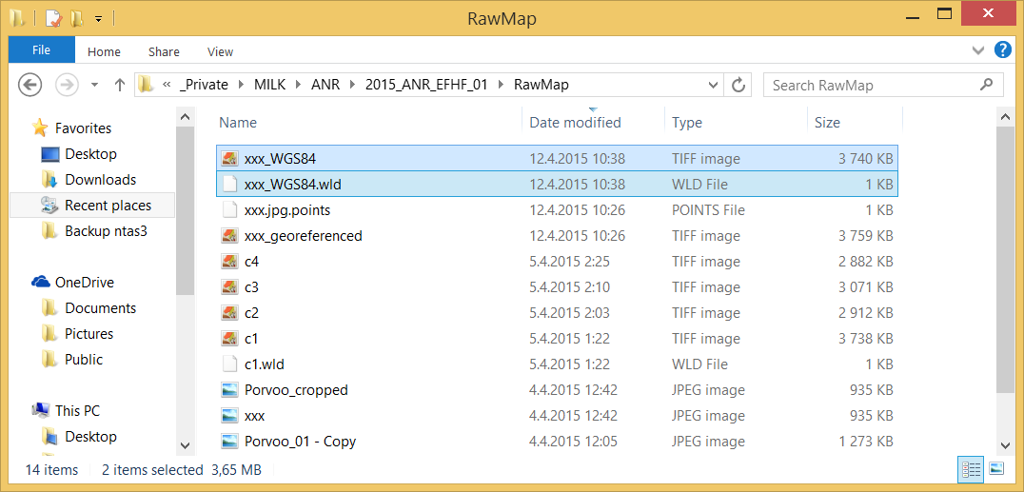

* Open the image file (*tiff) with a graphics program (Paint or similar) and save it as a **png** file.
* Rename the file with extension WLD to a file with extension PGW (In above example, rename the xxx_wGS84.**wld** file to xxx_wGS84.**pgw**)

In case you have black borders, you can remove it as follows:

Use **clipping** and cut off the black borders.

* Open a new QGIS project
* Load the map file to be clipped
* Select “Raster”-Extraction”-“Clipper…”

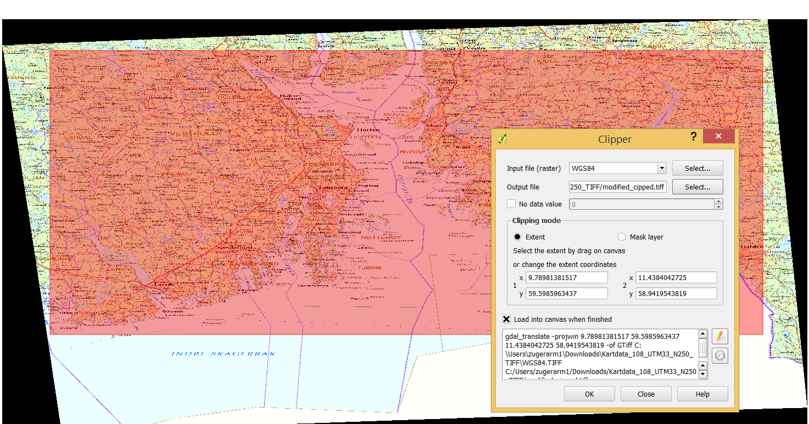

You may now define with you mouse the map area, based on the loaded map.

Then select the small pen icon on the pop-up window, and append manually the text ***–co worldfile=yes***to the existing text, then press OK.

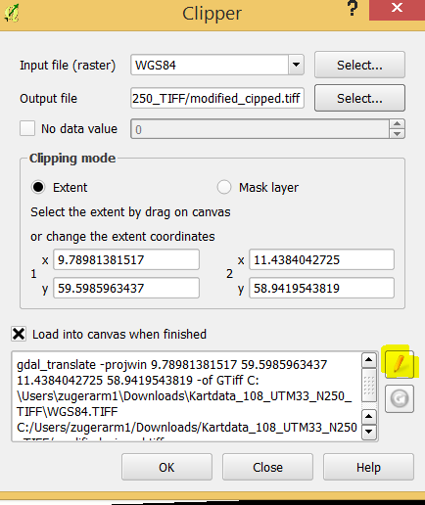 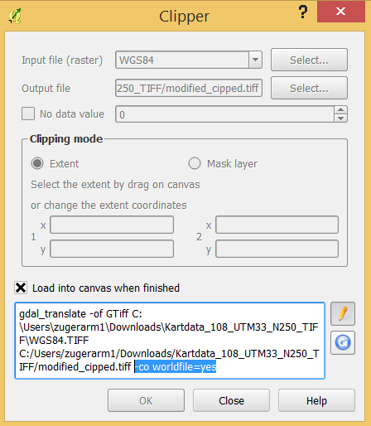

# Importing the new map into the ANR Scoring and Visualization software

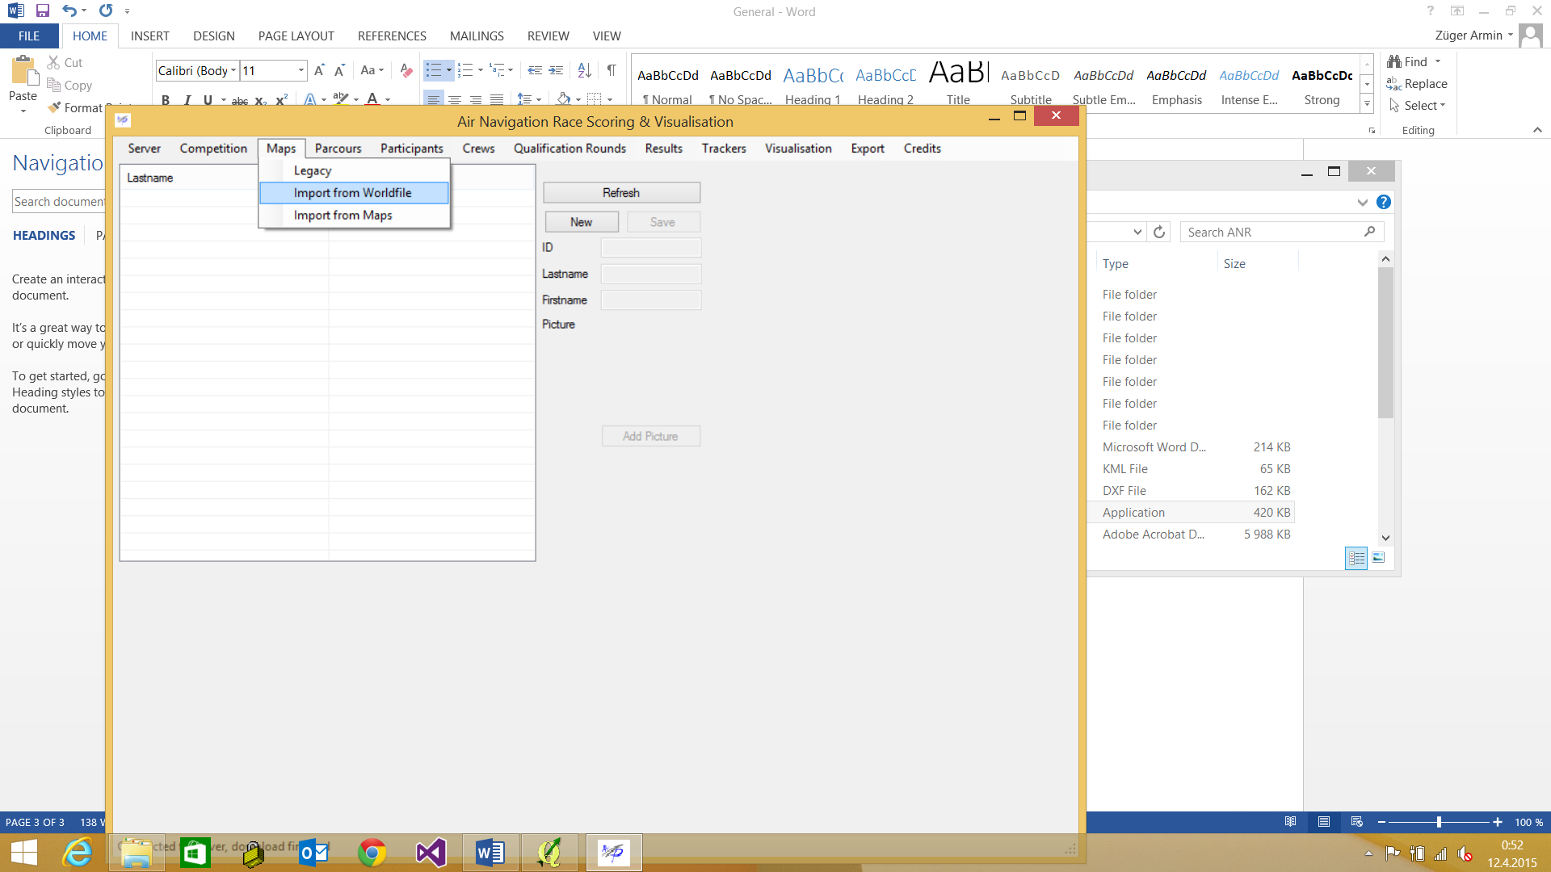

Import the newly created and referenced map

**Note**:

* When loading the world file, you may receive an error about the Input string format (see picture)
* Most likely the output of the world file contains the ‘wrong’ decimal separator
* (the decimal separator is defined in your PC settings (Regional settings)
* Open the world file manually (use any text editor) and change the decimal separator in the world file - depending on you actual settings - from a dot (.) to a comma (,) or from a comma to a dot.

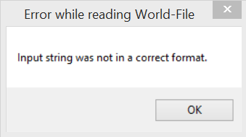

**After a successful map import: verify that the coordinates shown in the lower left window are consistent with the expected coordinates of the map section**. NOTE: a worldfile with a decimal separator may cause issues (longitude/latitude shown without decimal separator etc. Change either manually the decimal separator in the worldfile or change the decimal separator in your PC settings (may require restart), then re-import

